**Report on Practical 1**

**Make Ethernet Cables RJ45: Straight Through and Crossover**

**1. Aims**

* Learn how to assemble RJ45 connectors on Ethernet cables for each configuration.

**2. Objectives**

* Familiarize with different network cable types and standards.
* Test the connectivity of completed Ethernet cables.
* Understand the differences between straight-through and crossover Ethernet cables.

**3. Background**

* Ethernet cables are used in network connections and need specific wiring configurations for different purposes.
* RJ45 stands for Registered Jack 45 and is the most commonly used connector in wired networks. It supports greater bandwidth with greater speed and cheaper.
* Straight-through cables connect different types of devices and provide a connection that only allows one end to communicate at any given moment connect.
* Crossover cables are used to connect two similar devices directly together, such as computers or hubs.

**4. Procedure**

* Gather necessary tools:

Ethernet cable

RJ45 connectors

Wire stripper

Wire crimping tool

Cable tester.

* Strip approximately 1 inch of the cable jacket and arrange the wires in the appropriate order.

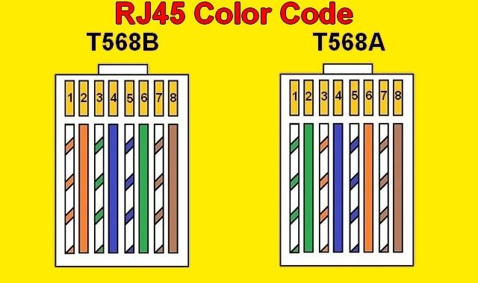

* Insert the wires into the RJ45 connector and crimp to secure the connector.
* Repeat for the other end (same for straight-through, reversed for crossover).
* Use cable tester to check if its connected and functions.

**5. Conclusion**

* We successfully create Ethernet cables after following the procedures. After gathering all the necessities, we arrange the wire according to the colour code and crimping it to keep it secured then testing it to make sure it functions well. With the correct wiring configurations we achieve effective network connectivity.

**6. References**

* YouTube video: *How to Make Ethernet Cable RJ45 - Straight Through & Crossover* <https://www.youtube.com/watch?v=Uw8FSXx4dnU>